**COMSATS UNIVERSITY ISLAMABAD, ATTOCK CAMPUS**

**DEPARTMENT OF COMPUTER SCIENCE**

**ASSIGNMENT: ASSIGNMENT NO 03**

**SUBJECT: MOBILE APPLICATION DEVELOPMENT**

**PROGRAM: BSSE-6**

**SUBMITTED TO:**

**SIR MUHAMMAD KAMRAN**

**SUBMITTED BY:**

**MALAIKA(sp22-bse-003)**

**DATE: 10TH, DEC 2024**

**APP.JS:**

import React from 'react';

import { NavigationContainer } from '@react-navigation/native';

import { createStackNavigator } from '@react-navigation/stack';

import SignupScreen from './components/SignupScreen';

import LoginScreen from './components/LoginScreen';

import HomeScreen from './components/HomeScreen';

const Stack = createStackNavigator();

const App = () => {

  return (

    <NavigationContainer>

      <Stack.Navigator initialRouteName="Signup">

        <Stack.Screen name="Signup" component={SignupScreen} />

        <Stack.Screen name="Login" component={LoginScreen} />

        <Stack.Screen name="Home" component={HomeScreen} />

      </Stack.Navigator>

    </NavigationContainer>

  );

};

**SIGNIN SCREEN:**

export default App;

import React, { useState } from 'react';

import { View, Text, TextInput, TouchableOpacity, StyleSheet, Alert } from 'react-native';

const SignupScreen = ({ navigation }) => {

  const [email, setEmail] = useState('');

  const [password, setPassword] = useState('');

  const handleSignup = () => {

    const emailRegex = /^[a-zA-Z0-9._%+-]+@[a-zA-Z0-9.-]+\\.[a-zA-Z]{2,}$/;

    const passwordRegex = /^(?=.*[A-Z])(?=.*[a-z])(?=.*\\d)(?=.*[@$!%*?&#])[A-Za-z\\d@$!%*?&#]{8,}$/;

    if (!emailRegex.test(email)) {

      Alert.alert('Invalid Email', 'Please enter a valid email address.');

      return;

    }

    if (!passwordRegex.test(password)) {

      Alert.alert(

        'Weak Password',

        'Password must be at least 8 characters long, include at least one uppercase letter, one lowercase letter, one number, and one special character.'

      );

      return;

    }

    navigation.navigate('Login');

  };

  return (

    <View style={styles.container}>

      <Text style={styles.title}>Sign Up</Text>

      <Text style={styles.subtitle}>Join us and start your journey</Text>

      <TextInput

        style={styles.input}

        placeholder="Enter your email"

        placeholderTextColor="#aaa"

        value={email}

        onChangeText={setEmail}

        keyboardType="email-address"

        autoCapitalize="none"

      />

      <TextInput

        style={styles.input}

        placeholder="Enter your password"

        placeholderTextColor="#aaa"

        value={password}

        onChangeText={setPassword}

        secureTextEntry

      />

      <TouchableOpacity style={styles.signupButton} onPress={handleSignup}>

        <Text style={styles.signupButtonText}>Sign Up</Text>

      </TouchableOpacity>

      <TouchableOpacity onPress={() => navigation.navigate('Login')}>

        <Text style={styles.loginText}>

          Already have an account? <Text style={styles.loginLink}>Log In</Text>

        </Text>

      </TouchableOpacity>

    </View>

  );

};

const styles = StyleSheet.create({

  container: {

    flex: 1,

    backgroundColor: '#e3f2fd',

    padding: 20,

    justifyContent: 'center',

  },

  title: {

    fontSize: 30,

    fontWeight: 'bold',

    color: '#1e88e5',

    textAlign: 'center',

    marginBottom: 10,

  },

  subtitle: {

    fontSize: 16,

    color: '#42a5f5',

    textAlign: 'center',

    marginBottom: 30,

  },

  input: {

    borderWidth: 1,

    borderColor: '#90caf9',

    backgroundColor: '#fff',

    borderRadius: 10,

    padding: 15,

    marginBottom: 20,

    fontSize: 16,

    color: '#1e88e5',

  },

  signupButton: {

    backgroundColor: '#1e88e5',

    paddingVertical: 15,

    borderRadius: 10,

    marginBottom: 20,

  },

  signupButtonText: {

    fontSize: 16,

    fontWeight: 'bold',

    color: '#fff',

    textAlign: 'center',

  },

  loginText: {

    fontSize: 14,

    color: '#1e88e5',

    textAlign: 'center',

  },

  loginLink: {

    color: '#1565c0',

    fontWeight: 'bold',

  },

});

export default SignupScreen;

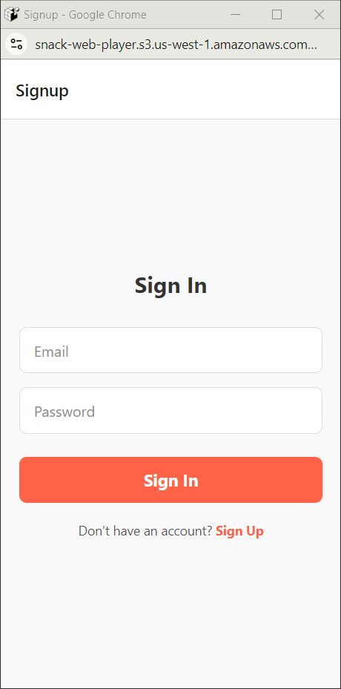

**Login Screen:**

import React, { useState } from 'react';

import {

  View,

  Text,

  StyleSheet,

  TextInput,

  TouchableOpacity,

  Alert

} from 'react-native';

const LoginScreen = () => {

  const [email, setEmail] = useState('');

  const [password, setPassword] = useState('');

  const handleLogin = () => {

    if (!email || !password) {

      Alert.alert('Error', 'Please enter both email and password.');

      return;

    }

    Alert.alert('Success', 'Logged in successfully!');

  };

  return (

    <View style={styles.container}>

      <Text style={styles.title}>Login</Text>

      <TextInput

        style={styles.input}

        placeholder="Email"

        placeholderTextColor="#8c8c8c"

        value={email}

        onChangeText={setEmail}

        keyboardType="email-address"

      />

      <TextInput

        style={styles.input}

        placeholder="Password"

        placeholderTextColor="#8c8c8c"

        value={password}

        onChangeText={setPassword}

        secureTextEntry

      />

      <TouchableOpacity style={styles.button} onPress={handleLogin}>

        <Text style={styles.buttonText}>Login</Text>

      </TouchableOpacity>

      <Text style={styles.footerText}>Don't have an account? <Text style={styles.link}>Sign Up</Text></Text>

    </View>

  );

};

const styles = StyleSheet.create({

  container: {

    flex: 1,

    justifyContent: 'center',

    alignItems: 'center',

    backgroundColor: '#f0f0f0',

    padding: 20

  },

  title: {

    fontSize: 26,

    fontWeight: 'bold',

    color: '#2f4f4f',

    marginBottom: 30

  },

  input: {

    width: '100%',

    height: 50,

    backgroundColor: '#fff',

    borderRadius: 10,

    paddingHorizontal: 15,

    fontSize: 16,

    color: '#333',

    marginBottom: 15,

    borderWidth: 1,

    borderColor: '#ccc'

  },

  button: {

    width: '100%',

    height: 50,

    backgroundColor: '#4682b4',

    justifyContent: 'center',

    alignItems: 'center',

    borderRadius: 10,

    marginTop: 10

  },

  buttonText: {

    color: '#fff',

    fontSize: 18,

    fontWeight: 'bold'

  },

  footerText: {

    marginTop: 20,

    fontSize: 14,

    color: '#555'

  },

  link: {

    color: '#4682b4',

    fontWeight: 'bold'

  }

});

export default LoginScreen;

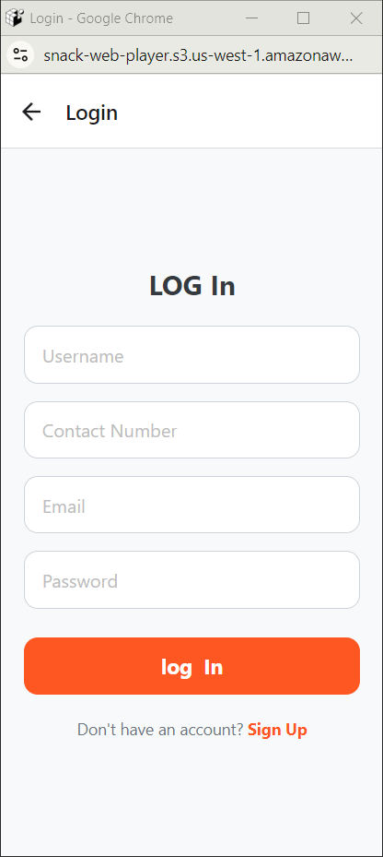

**Components:**

**Home Screen:**

import React from 'react';

import { View, Text, Image, StyleSheet, TouchableOpacity } from 'react-native';

const ProfileSection = ({ profile }) => {

  return (

    <View style={styles.container}>

      <View style={styles.header}>

        <TouchableOpacity>

          <Image source={require('../assets/back.png')} style={styles.icon} />

        </TouchableOpacity>

        <Text style={styles.headerText}>My Profile</Text>

        <TouchableOpacity>

          <Image source={require('../assets/edit.png')} style={styles.icon} />

        </TouchableOpacity>

      </View>

      <Image source={require('../assets/profile.jpg')} style={styles.profileImage} />

      <Text style={styles.profileName}>{profile.name}</Text>

      <View style={styles.statsContainer}>

        <View style={styles.statItem}>

          <Image source={require('../assets/product.png')} style={styles.statIcon} />

          <Text style={styles.stats}>{profile.productSells}</Text>

        </View>

        <View style={styles.statItem}>

          <Image source={require('../assets/earning.png')} style={styles.statIcon} />

          <Text style={styles.stats}>{profile.earning}</Text>

        </View>

      </View>

    </View>

  );

};

const styles = StyleSheet.create({

  container: {

    alignItems: 'center',

    marginBottom: 20,

    backgroundColor: '#fff',

    padding: 20,

    borderRadius: 10

  },

  header: {

    flexDirection: 'row',

    justifyContent: 'space-between',

    alignItems: 'center',

    width: '100%',

    paddingHorizontal: 10,

    marginBottom: 20

  },

  headerText: {

    fontSize: 18,

    fontWeight: 'bold'

  },

  icon: {

    width: 24,

    height: 24

  },

  profileImage: {

    width: 100,

    height: 100,

    borderRadius: 50,

    marginBottom: 10

  },

  profileName: {

    fontSize: 20,

    fontWeight: 'bold',

    marginBottom: 10

  },

  statsContainer: {

    flexDirection: 'row',

    justifyContent: 'space-around',

    width: '80%'

  },

  statItem: {

    alignItems: 'center'

  },

  statIcon: {

    width: 24,

    height: 24,

    marginBottom: 5

  },

  stats: {

    fontSize: 16,

    color: '#888'

  }

});

export default ProfileSection;

**Detail screen:**

import React from 'react';

import { View, Text, Image, StyleSheet } from 'react-native';

const OrderItem = ({ order }) => {

  return (

    <View style={styles.orderItem}>

      <Image source={order.imageUrl} style={styles.orderImage} />

      <View style={styles.orderTextContainer}>

        <Text style={styles.orderText}>{order.items}</Text>

        <Text style={styles.orderDate}>{order.date}</Text>

        <Text style={styles.orderPrice}>{order.price}</Text>

      </View>

    </View>

  );

};

const styles = StyleSheet.create({

  orderItem: {

    flexDirection: 'row',

    paddingVertical: 10,

    borderBottomWidth: 1,

    borderBottomColor: '#eee',

    alignItems: 'center',

    backgroundColor: '#fff',

    borderRadius: 10,

    padding: 10,

    marginBottom: 10

  },

  orderImage: {

    width: 50,

    height: 50,

    borderRadius: 25,

    marginRight: 10

  },

  orderTextContainer: {

    flex: 1

  },

  orderText: {

    fontSize: 16

  },

  orderDate: {

    fontSize: 14,

    color: '#888'

  },

  orderPrice: {

    fontSize: 16,

    fontWeight: 'bold'

  }

});

export default OrderItem;

